Title: Reimagining Colonialism and Empire: Creative Approaches to Marginalised Narratives at the Oriental Museum
Sierra Kaag, Department of English Studies, Durham University, sierra.e.kaag@durham.ac.uk
Abstract
Museums are under increasing pressure to acknowledge – and in some cases make reparations for – unethical collecting practices of the past, and also to address the legacy of institutional bias that has historically favoured Western cultural narratives. Gaps in documentation mean that the histories of many objects collected during the colonial era remain incomplete. Like many museums specialising in non-European material culture, the collections of Durham University’s Oriental Museum encompass objects whose provenance is to some degree unknown – and in some cases unknowable. Confronting these gaps can shed light on the impact of colonialism on collecting practice, but to do so requires innovative approaches to object interpretation.
Keywords: Decolonisation, object-based interpretation, creative writing, audience engagement, interdisciplinarity
Main article
My research focuses on the potential of creative texts for interpreting museum objects with complex or contested histories – for exploring the uncomfortable and the unknown in museum collections. As a writer of historical narratives who spent over a decade working in the museum sector, I have one foot firmly in the Creative Writing camp, with the other planted in Museum Studies. My project takes museum objects as the basis for creative interpretation and formal experimentation, moving beyond the label to delve into collections’ complex histories. In the first of three case studies, I examine two collections that were acquired by Durham University in the 1950s and form the core of the Oriental Museum today.
The Northumberland Collection and the Malcolm MacDonald Collection illustrate key moments during the period of British colonial power. The fourth Duke of Northumberland began acquiring ancient Egyptian artefacts in the mid-1820s, a period during which competing French and British interests exacerbated political instability in the region. The British diplomat Malcolm MacDonald – son of Prime Minister Ramsay MacDonald, and later Chancellor of Durham University – amassed much of his collection of Chinese ceramics during the years following the Second World War, when his official role in East Asia afforded him access to treasures that flooded the art market as a direct result of the upheaval caused by the Chinese Civil War (MacDonald 2018).
Clearly, the circumstances under which these objects were collected are important to our understanding of the historical and political forces that have shaped and continue to shape our society. Yet conventional, fact-based interpretive texts cannot effectively grapple with the legacies of conflict and privilege in collections such as the Oriental Museum’s. Short-form texts, such as identification labels and wall panels, are restricted in their length and tone, and generally convey a maximum of three key messages in the interest of accessibility. Some forms of interpretation, such as museum collection catalogues, may provide greater detail, but also assume a high degree of specialist knowledge on the part of the reader, while oversimplified texts fail to acknowledge contentious issues and sociohistorical contexts, frustrating those who wish to know more (Hooper-Greenhill 2000). In view of these limitations, I found myself asking: what other forms of interpretation might lend themselves to exploring marginalised narratives in museum collections? How can gaps in provenance highlight the ethical issues associated with British collecting during the imperial era?
Although creative writing has long been used as a pedagogical tool in museum education programmes, I chose to approach object-based fictional narratives and creative nonfiction as museological practices in their own right. My textual experimentation on objects from the Northumberland and MacDonald collections builds on the work of Saidiya Hartman, who developed a practice of ‘critical fabulation’ during her research on the Transatlantic slave trade (Hartman 2008). Expanding upon scant historical documentation of these journeys, Hartman constructs imaginative counter-narratives that shift the focus from ships’ ledgers to the experiences of the enslaved, bringing context and nuance to archival data (Hartman 2016).
Adapting and applying critical fabulation to objects at the Oriental Museum allows for an examination of colonial collecting practices, the multiple significances of objects, and the incomplete, inherently biased nature of much museum documentation. In one example of this approach, I wrote a piece based on a steatite seal from the reign of the Egyptian Pharaoh Amenhotep III, which entered the Duke of Northumberland’s collection through channels unknown. In this text, I expand upon Nanouschka Bürstrom’s reframing of object biographies – frequently used in the field of archaeology to present an object’s history and trajectory – as it-narratives, a literary form that emerged in the 18th century in which an object-as-protagonist relates the plot from a nonhuman perspective (Bürstrom 2014). Moving through space and time, and from owner to owner, an object acts as a lens through which the reader views the world. By creating an it-narrative that weaves known facts (the seal’s place of origin, its status as part of the duke’s collection) with one of many possible trajectories, I highlight the changes in its function, value, and significance as a result of the transfer of ownership.
As an extension of my own creative work and research on the Oriental Museum’s collections, I have run writing workshops for Museum and Artefact Studies and Creative Writing MA students with the aim of encouraging emerging museum professionals to engage creatively with complex object histories, and emerging writers to apply literary techniques to museum objects. The participants’ texts will be disseminated in cooperation with the Oriental Museum, creating a supplementary layer of interpretation that brings the resource of creative writing to our understanding of objects and their histories.
In this case study, I foreground the limitations of conventional interpretation and promote a more pluralistic and authentic relationship with museum audiences through creative writing. By moving beyond ‘factual’ and short-form texts and applying the practice of critical fabulation to object histories, I encourage readers to remain open to the polysemic potential of objects. After all, an ancient Egyptian seal may be considered a devotional object, a commodity, a curiosity, an artefact, or any number of things, depending on one’s perspective. Creative texts embrace the interpretive potential of narrative, fostering a deeper and more nuanced engagement with the themes of colonialism, conflict, and institutional authority.
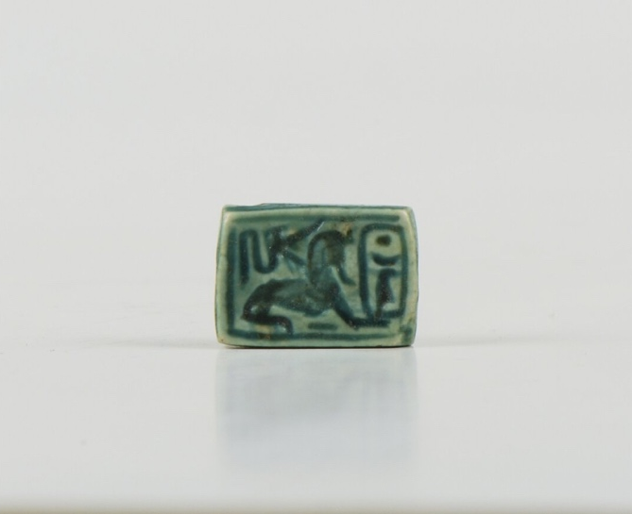
Figure: Seal (faience), Amenhotep III/Amenophis III/Nebmaatre, EG6360, 10 x 5 x 15mm, Purchased from Hugh Percy, 10th Duke of Northumberland, <https://iiif.durham.ac.uk/index.html?manifest=a6258&canvas=71905>
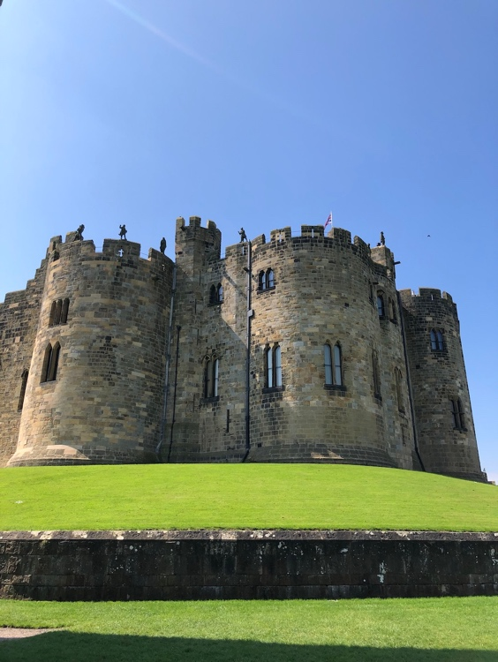
Figure: Alnwick Castle, seat of the Dukes of Northumberland
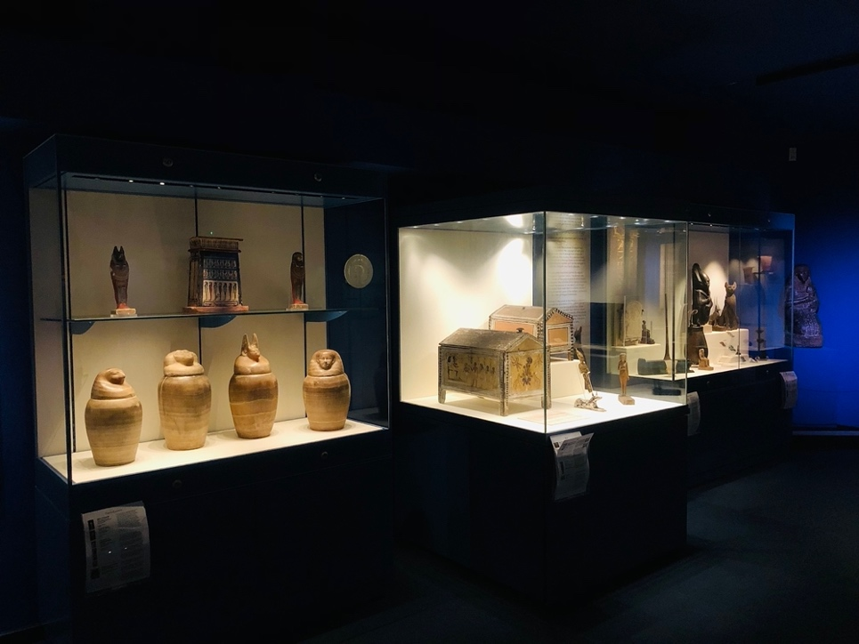
Figure: Installation view of objects from the Northumberland Collection on display at the Oriental Museum
Bibliography
Burström, Nanouschka M., ‘Things in the Eye of the Beholder: A Humanistic Perspective on Archaeological Object Biographies’, in Norwegian Archaeological Review, 47.1 (2014), pp. 65-82, doi:10.1080/00293652.2014.909877
Hartman, Saidiya, ‘The Dead Book Revisited’, in History of the Present, 6.2 (2016), pp. 208-215, doi:10.5406/historypresent.6.2.0208
Hartman, Saidiya, ‘Venus in Two Acts’, in Small Axe: A Journal of Criticism, 12 (2008), pp. 1-14, doi:10.1215/-12-2-1
Hooper-Greenhill, Eilean, Museums and the Interpretation of Visual Culture (London: Routledge, 2000)
MacDonald, Malcolm J., The Pleasures and Pains of Collecting (Durham: The Friends of the Oriental Museum, 2018)

